|  |  |  |  |  |  |  |  |  |
| --- | --- | --- | --- | --- | --- | --- | --- | --- |
| MAD Project Evaluation 1 – Regular Intake 2021 | | | | | | | | |
| Group Name: | **Strong Ties** | |  |  | Batch: | **Malabe G7** | | |
| Student ID | Student Name | Consistency (Out of 2) | Appropriateness and Professionalism (Out of 3) | Usage of resource manager (Out of 4) | Out of box design ideas (Out of 3) | Report (Out of 8) | Total (Out of 20) | Comments |
| **IT20206246** | **Samarasinghe.S.A.K.S** |  |  |  |  |  |  |  |
| **IT20069018** | **Wijewardane.W.A.M.B** |  |  |  |  |  |  |
| **IT20205874** | **Jayakody.J.A.B.U** |  |  |  |  |  |  |
| **IT20225056** | **Benthara.B.W.H.T** |  |  |  |  |  |  |
|  |  |  |  |  |  |  |  |

Git Repository Link:

(If already created)

-------------------For Evaluators use only-------------------------------------------------------------------------------------

Evaluator’s name:

Others:

1. Introduction to the project

Since the emergence and popularization of smart phones, many mobile applications that track and record data about their users have been created. Applications in this category, that track and record health or activity data about their users, are typically called Wellness or Fitness Apps. Wellness Apps are designed to assist the user in pursuing a healthy lifestyle by encouraging them to perform positive activities, and improve lifestyle choices. Factors that are typically targeted by our application includes exercise, rest, and diet. Understanding the nature of this relationship is crucial when designing a Wellness App. Our Wellness App has he potential to motivate our users into maintaining a cycle of positive lifestyle decisions and/ or breaking a cycle of negative lifestyle decisions. Diet, exercise and rest can influence several physiological pathways associated with depression and a bidirectional relationship likely exists between depression and these lifestyle factors, thereby creating a potentially increasing cycle of influence.

Wellness App allows users to easily calculate their BMI value (Body Mass Index), Calorie value, Body Fat percentage, and MHR (Maximum Heart Rate). This app has the capable of calculating, tracking and displaying data relevant to user details. This application also enables individuals to become aware of deficiencies in their everyday habits and will hopefully encourage the user to self-regulate towards improvement. Users can view diet plans and workout plans according to their age range and the weight range. And also users get the ability to get the total liters of water they drink per day and reach the goal. After the calculation they can reset the data and begin fro a new day.

Users can get the use of our app and give us their feedback and view other user feedback. Then the developers can identify their ups and downs and can improve the application according to the user’s needs.

The overall goal is to show the user his or her wealthiness and help them to make choices that will result in a healthier lifestyle and also a happier life.

1. Individual Contribution

|  |  |
| --- | --- |
| **IT20206246 -**  Body Fat Details Management:  Add, update gender, age, height, and weight  Display value and the status  Calculation:  Body fat percentage calculation  History:  View, Delete history  Workout Plan:  Insert age and weight  View workout plan  Dashboard design | **IT20069018 -**  Medium Heart Rate Details Management:  Add, update age  Display value and the status  Calculation:  Medium Heart Rate calculation  History:  View, Delete history  User Feedback:  Insert, view feedback |
| **IT20205874 -**  Calorie Details Management:  Add, update age, gender, height, weight, and activity  Display value  Calculation:  Calorie value calculation  History:  View, Delete history  Diet Plan :  Insert age and weight  View diet plan | **IT20225056 -**  BMI Details Management:  Add, update age, height, and weight  Display value and the status  Calculation:  BMI calculation  History:  View, Delete history  Drink Water per Day:  Insert amount of water  View and delete total amount |

**UI Connections**

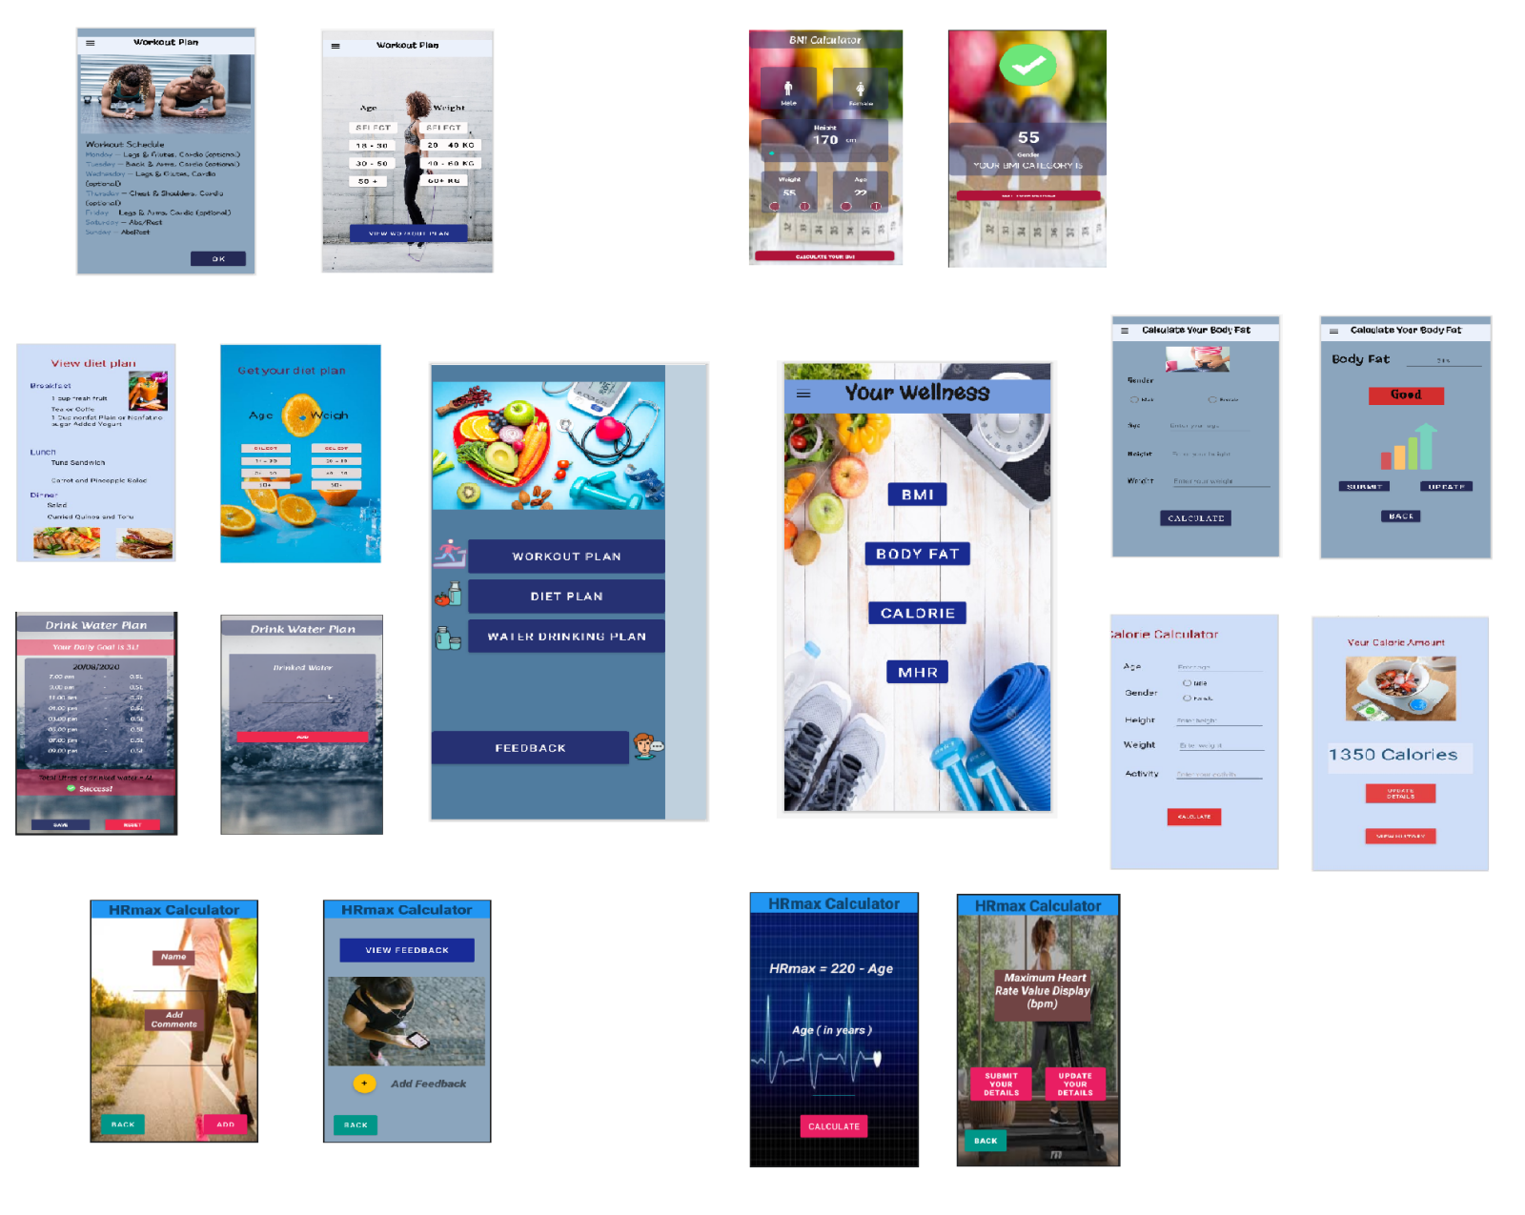

**IT20206246 - Body Fat Details Management, Calculation, History, Workout Plan**

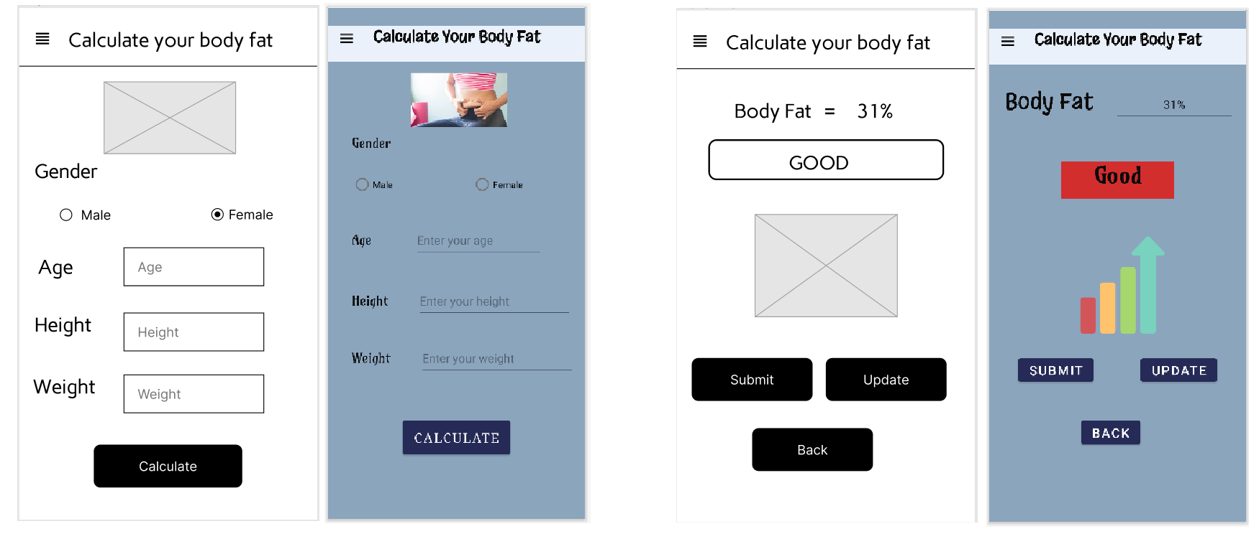

After clicking Calculate button user will redirect to this page. In here calculated body fat percentage will display. A status will appear as Good or Bad by examine the percentage. Then user can observe whether his body fat is good or bad.

After clicking Body Fat button user will redirect to this page. In here user can insert his gender, age, height, and weight in order to calculate his body fat percentage.

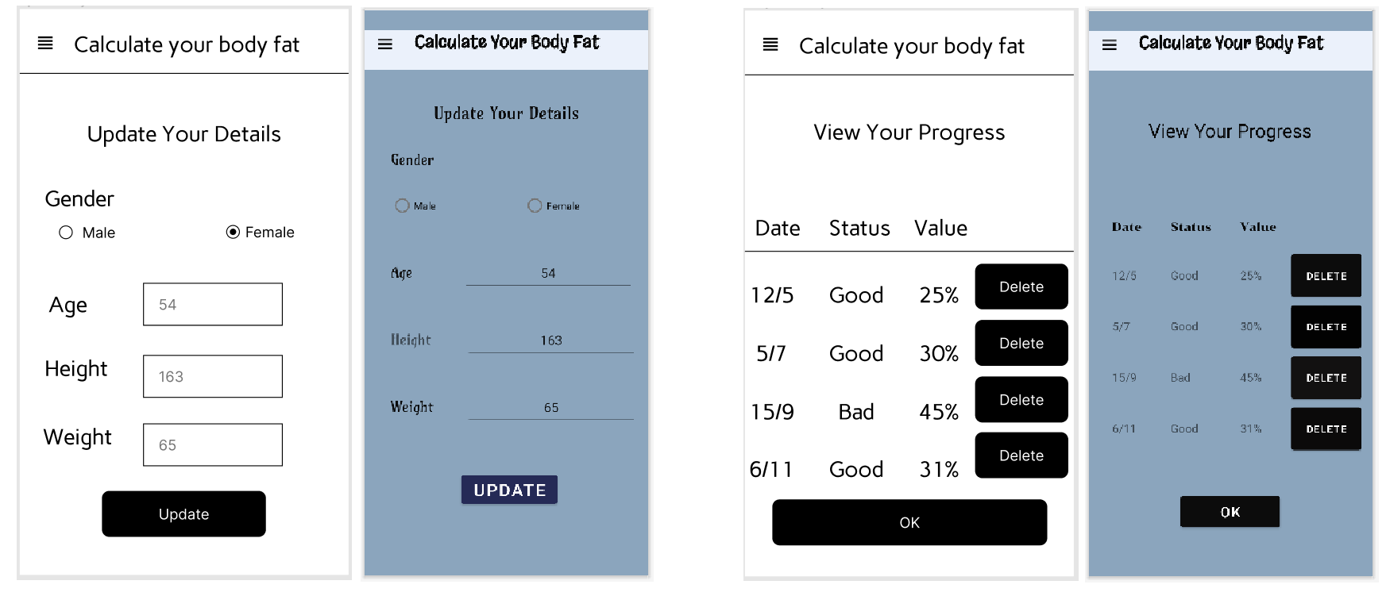

In here user can update his previously entered details.

This is the history of body fat percentage of the user. User can observe his progress through these details.

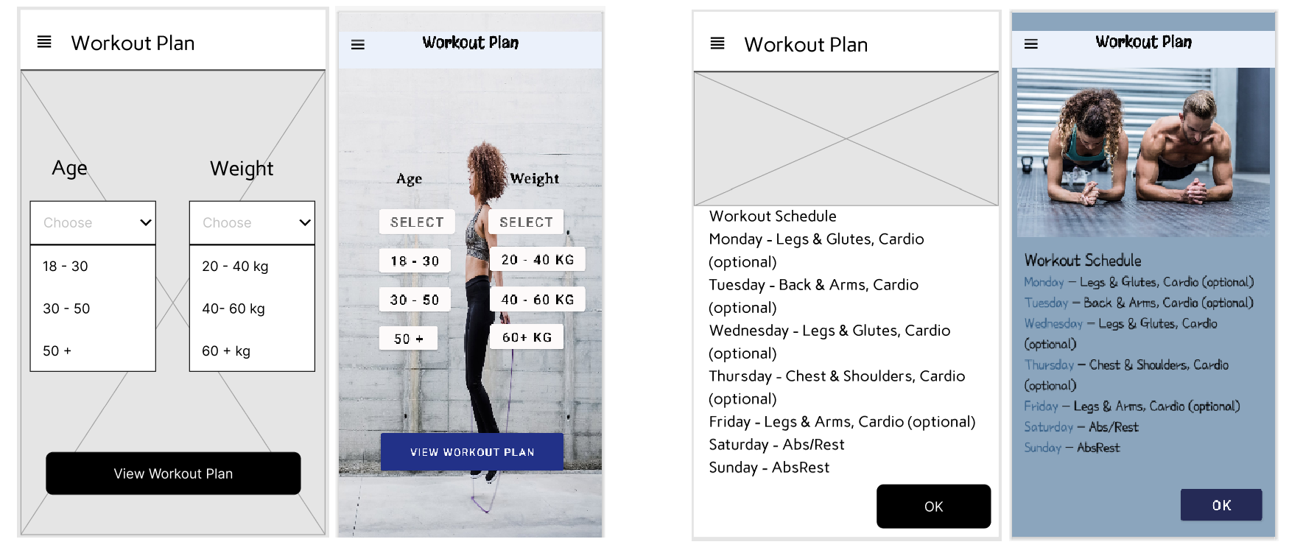

User can view workout plan after choosing their ranges. There are 9 workout plans available like this.

In here user can view his workout plan according to his age range and the weight range. User has to select the relevant age and weight range and click the View Workout Plan button. Then user can view workout plans for each category.

**Usage of resource files**

<resources>  
 <string name="app_name">Mad App</string>  
 <string name="tv_topic">Calculate Your Body Fat</string>  
 <string name="tv_gender">Gender</string>  
 <string name="rb_male">Male</string>  
 <string name="rb_female">Female</string>  
 <string name="tv_age">Age</string>  
 <string name="et_age">Enter your age</string>  
 <string name="hint_age">Enter your age</string>  
 <string name="tv_height">Height</string>  
 <string name="hint_height">Enter your height</string>  
 <string name="tv_weight">Weight</string>  
 <string name="hint_weight">Enter your weight</string>  
 <string name="btn_calculate">Calculate</string>  
 <string name="tv_display">Body Fat</string>  
 <string name="et_value">31%</string>  
 <string name="tv_status">Good</string>  
 <string name="btn_submit">Submit</string>  
 <string name="btn_update">Update</string>  
 <string name="btn_back">Back</string>  
 <string name="tv_update">Update Your Details</string>  
 <string name="tv_height2">Height</string>  
 <string name="et_height2">163</string>  
 <string name="tv_weight2">Weight</string>  
 <string name="er_weight">65</string>  
 <string name="btn_update2">Update</string>  
 <string name="tv_progress">View Your Progress</string>  
 <string name="tv_date">Date</string>  
 <string name="tv_status2" >Status</string>  
 <string name="tv_value">Value</string>  
 <string name="textView2">12/5</string>  
 <string name="textView3">Good</string>  
 <string name="textView4">25%</string>  
 <string name="textView8">5/7</string>  
 <string name="textView9">Good</string>  
 <string name="textView10">30%</string>  
 <string name="textView11">15/9</string>  
 <string name="textView12">Bad</string>  
 <string name="textView13">45%</string>  
 <string name="textView16">6/11</string>  
 <string name="textView18">Good</string>  
 <string name="textView17">31%</string>  
 <string name="btn_delete1">Delete</string>  
 <string name="btn_delete2">Delete</string>  
 <string name="btn_delete3">Delete</string>  
 <string name="btn_delete4">Delete</string>  
 <string name="btn_ok">OK</string>  
 <string name="tv_topic5">Workout Plan</string>  
 <string name="tv_age_d">Age</string>  
 <string name="tv_weight_d">Weight</string>  
 <string name="tv_para"><![CDATA[Workout Schedule Monday - Legs & Glutes, Cardio (optional) Tuesday - Back & Arms, Cardio (optional) Wednesday - Legs & Glutes, Cardio (optional) Thursday - Chest & Shoulders, Cardio (optional) Friday - Legs & Arms, Cardio (optional) Saturday - Abs/Rest Sunday - AbsRest]]></string>  
 <string name="btn_ok2">OK</string>  
 <string name="btn_1">Select</string>  
 <string name="btn_2">Select</string>  
 <string name="btn_3">18 - 30</string>  
 <string name="btn_4">20 - 40 kg</string>  
 <string name="btn_5">30 - 50</string>  
 <string name="btn_6">40 - 60 kg</string>  
 <string name="btn_7">50 +</string>  
 <string name="btn_8">60+ kg</string>  
 <string name="tv_topic6">Your Wellness</string>  
 <string name="btn_bmi">BMI</string>  
 <string name="btn_fat">Body Fat</string>  
 <string name="btn_calorie">Calorie</string>  
 <string name="btn_mhr">MHR</string>  
 <string name="btn_workout">Workout Plan</string>  
 <string name="btn_diet">Diet Plan</string>  
 <string name="btn_water">Water Drinking Plan</string>  
 <string name="btn_fdback">Feedback</string>  
 <string name="btn_back2">HISTORY</string>  
 <string name="btn_view2">View Workout Plan</string>  
</resources>

<resources>  
 <color name="purple_200">#FFBB86FC</color>  
 <color name="purple_500">#FF6200EE</color>  
 <color name="purple_700">#FF3700B3</color>  
 <color name="teal_200">#FF03DAC5</color>  
 <color name="teal_700">#FF018786</color>  
 <color name="black">#FF000000</color>  
 <color name="white">#FFFFFFFF</color>

</resources>

**CRUD operations and functionality of the components**

My part is Body fat percentage calculator and workout plan management.

**Components and principals**

I used light colors for background which will attract users as well as for the attractiveness. I used various colourful pictures related for app to get a good impression. I used grid view to display some details. So user can read easily. I used icons and buttons for every page.

**Crud operations**

Body fat calculator

When user clicks Body Fat button in the dashboard user will redirect to the bod fat page. In there user can insert his gender, age, height and weight. They will record in the database.if any of the text field is not filled system will pop out a warning to fill that text field. After user click on the calculate button user can view his Body fat percentage. System will display whether his body fat percentage is good or bad. Then user can save his body fat percentage details b clicking submit button. If the user wants to update his details he can click update button and update his gender, age, height and weight. After clicking the submit button user can view his body fat percentage history. It includes the date of submit , body fat percentage of each day and the state for relevant percentage. User can delete the history by clicking the delete button.

Workout plan

When user clicks Workout plan in menu bar he will redirect to the workout plan page. In there user has to select his age range and the weight range. After the selection user has to click the view workout plan button. Then user can view workout plan according to his selection.

When designing the interfaces we focused on color balancing.

**IT20205874 - Calorie Details Management, Calculation, History, Diet Plan**

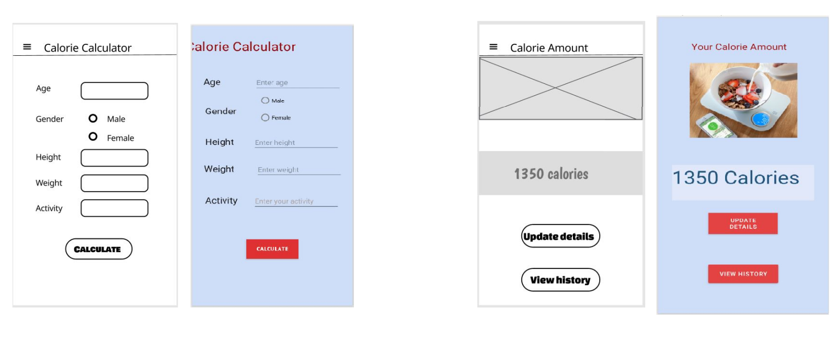

User can view his calorie amount. In this page it shows the calorie amount after calculating. Those calculations are done according to the details that the user provided.

Interface to get details of user to calculate calorie amount.user need to insert his age,gender,height,weight and activity.

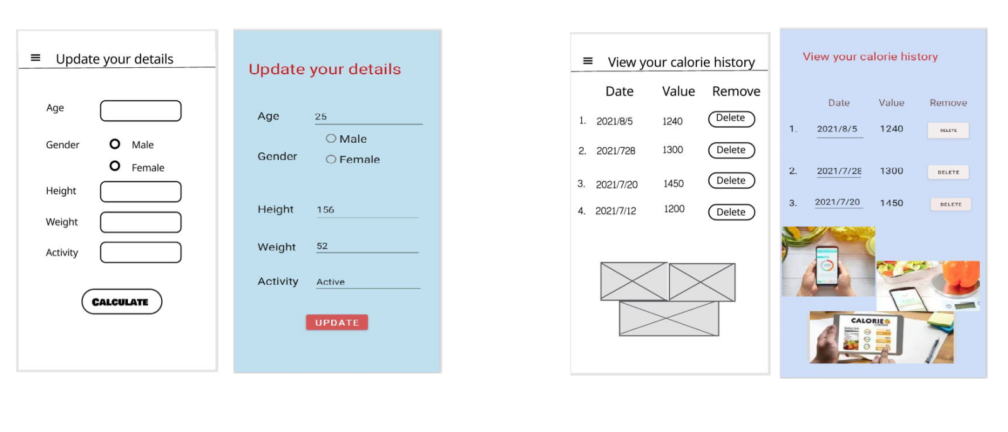

From this page user can update his details if he need.

If he input a wrong data and he can click on the update button and correct the data. So he do not need to go back.

Users will be able to view their calorie history. From this, user can get an overall idea about his calorie amount and he can know whether there is an improvement or not.And if he need he can delete the calorie history.

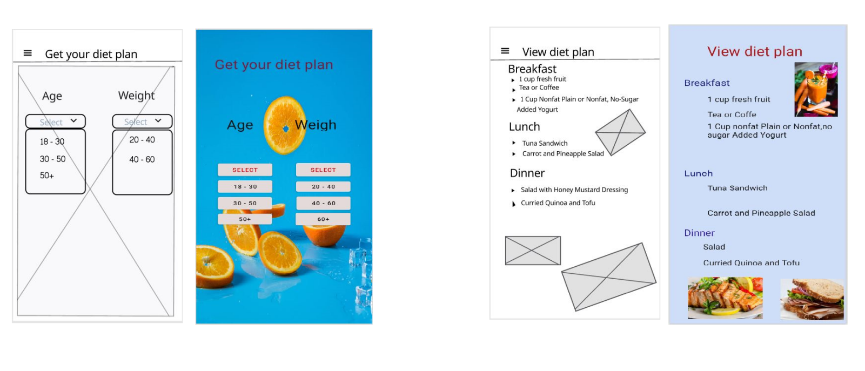

Users can view the diet plan. This diet plan is based on the age range and weight range.

From this interface user can select their age range and weight range.

**Usage of resource files**

<resources>  
 <string name="app_name">Calorie calculator</string>  
 <string name="calorieCalc">Calorie Calculator</string>  
 <string name="age1">Age</string>  
 <string name="agein2">Enter age</string>  
 <string name="gender1">Gender</string>  
 <string name="height">Height</string>  
 <string name="height2">Enter height</string>  
 <string name="weight1">Weight</string>  
 <string name="weight">Enter weight</string>  
 <string name="male2">Male</string>  
 <string name="female2">Female</string>  
 <string name="Activity">Activity</string>  
 <string name="activity2">Enter your activity</string>  
 <string name="calculate">CALCULATE</string>  
 <string name="calorieCalc1">Calculate your calorie amount</string>  
 <string name="amount1">Your Calorie Amount</string>  
 <string name="dis1">1350 Calories</string>  
 <string name="update1">Update details</string>  
 <string name="up1">Update your details</string>  
 <string name="age12">Age</string>  
 <string name="age43">Enter age</string>  
 <string name="gender12">Gender</string>  
 <string name="male12">Male</string>  
 <string name="female12">Female</string>  
 <string name="height">Height</string>  
 <string name="height34">156</string>  
 <string name="age34">25</string>  
 <string name="weight34">Weight</string>  
 <string name="weight5">52</string>  
 <string name="activity12">Activity</string>  
 <string name="activity4" />  
 <string name="activity45">Active</string>  
 <string name="update12">Update</string>  
 <string name="view">View your calorie history</string>  
 <string name="date">Date</string>  
 <string name="value">Value</string>  
 <string name="remove">Remove</string>  
 <string name="no1">1</string>  
 <string name="nu1">1.</string>  
 <string name="dt1">2021/8/5</string>  
 <string name="dat1">2021/8/5</string>  
 <string name="val1">1240</string>  
 <string name="del1">delete</string>  
 <string name="dat2">2.</string>  
 <string name="date2">2021/7/28</string>  
 <string name="val2">1300</string>  
 <string name="del2">Delete</string>  
 <string name="nu3">3.</string>  
 <string name="dat3">2021/7/20</string>  
 <string name="btn3">Delete</string>  
 <string name="val3">1450</string>  
 <string name="diet1">Get your diet plan</string>  
 <string name="age67">Age</string>  
 <string name="diet2">Get your diet plan</string>  
 <string name="age3">Age</string>  
 <string name="weight23">Weight</string>  
 <string name="sele1">Select</string>  
 <string name="select1">Select</string>  
 <string name="select2">Select</string>  
 <string name="ag12">18 - 30</string>  
 <string name="ag2">30 - 50</string>  
 <string name="ag2">30 - 50</string>  
 <string name="ag2">30 - 50</string>  
 <string name="ag3">50+</string>  
 <string name="sel4">20 - 40</string>  
 <string name="sel5">40 - 60</string>  
 <string name="sel6">60+</string>  
 <string name="view1">View diet plan</string>  
 <string name="break1">Breakfast</string>  
 <string name="b1">1 cup fresh fruit</string>  
 <string name="b2">Tea or Coffe</string>  
 <string name="b3">1 Cup nonfat Plain or Nonfat,no sugar Added Yogurt</string>  
 <string name="lunch1">Lunch</string>  
 <string name="l1">Tuna Sandwich</string>  
 <string name="l2">Carrot and Pineapple Salad</string>  
 <string name="dinner1">Dinner</string>  
 <string name="d1">Salad</string>  
 <string name="d2">Curried Quinoa and Tofu</string>  
 <string name="btnview">View history</string>  
</resources>

<?xml version="1.0" encoding="utf-8"?>  
<resources>  
 <color name="purple_200">#FFBB86FC</color>  
 <color name="purple_500">#FF6200EE</color>  
 <color name="purple_700">#FF3700B3</color>  
 <color name="teal_200">#FF03DAC5</color>  
 <color name="teal_700">#FF018786</color>  
 <color name="black">#FF000000</color>  
 <color name="white">#FFFFFFFF</color>  
 <color name="gen1">#C0E0EF</color>  
 <color name="ab">#CEDEF8</color>  
 <color name="yu">#CEDEF8</color>  
 <color name="amount">#CEDEF8</color>  
</resources>

**CRUD operations and the entire functionality of the component**

**Calculate calorie amount**

Our system consists of an implementation where a customer can calculate their calorie amount. There is an interface to inserting, height, weight, sex, and activity level.

Activity level is organized as inactive, somewhat active, active, and very active. According to the activity level, the calorie amount is different. So there are four different equations to calculate the calorie amount according to the activity level. After inputting the details, it calculates the calorie amount.

When it displays the calorie amount there is a button to update details. One can update their early details by clicking on the update button. On the calorie display page, there is a button to view the calorie history. From there user can view their calorie history. In that interface, there is a button to delete the calorie history. user can delete his history from there.

**Diet plan**

In our system, there is a facility to get a diet plan according to their features. There is an interface to insert details of age and weight. There are three ranges of age and three ranges of weight. According to those ranges, one can get a diet plan. There are several different diet plans for the ages and weights.

when designing the interfaces we focused on color balancing.

**IT20225056 - BMI Details Management, Calculation, History, Drink Water Plan**

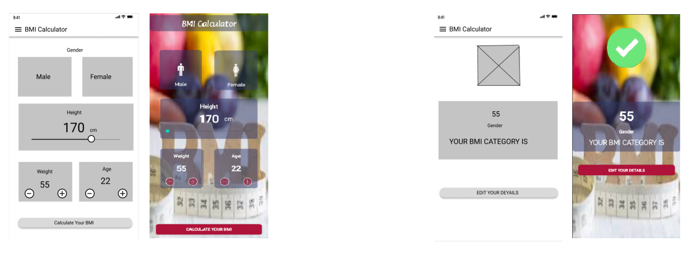

User can view status report about their BMI. In this page, user can see their BMI value and is it good or bad.

Interface to get details of user to calculate BMI value. User needs to insert his gender, height, weight and age.

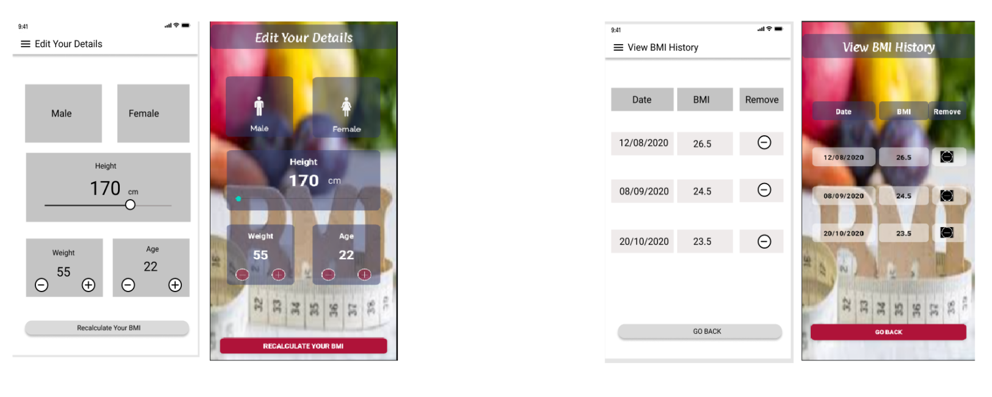

User will be able to view their BMI history from this page. From here user can view overview of the change of BMI. Also here user can delete BMI history.

From this page user can recalculate their BMI. If user wants to edit their details and recalculate BMI, it will be done from this page.

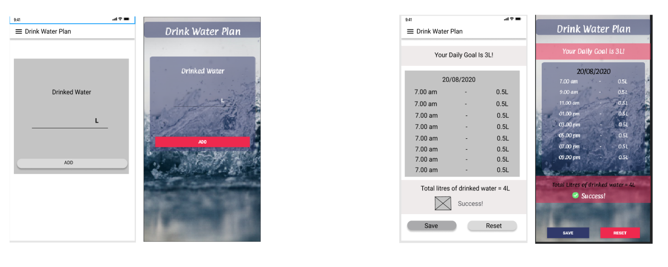

User can view the time and the liters of water drank that time. If he exceeded the goal he will see the success message. If he can't exceeded the goal he will see the fail message. Finally user can reset all the details for a new day.

From this interface user can enter the liters of water you drank in any time.

**Usage of resource files**

<resources>  
 <string name="app_name">BMI Calculator</string>  
 <string name="bmi_calculator">BMI Calculator</string>  
 <string name="male">Male</string>  
 <string name="female">Female</string>  
 <string name="weight">Weight</string>  
 <string name="txt1_55">55</string>  
 <string name="age">Age</string>  
 <string name="_22">22</string>  
 <string name="height">Height</string>  
 <string name="_170">170</string>  
 <string name="cm">cm</string>  
 <string name="calculate_your_bmi">Calculate Your BMI</string>  
 <string name="txt2_55">55</string>  
 <string name="gender">Gender</string>  
 <string name="your_bmi_category_is">YOUR BMI CATEGORY IS</string>  
 <string name="edit_your_details">Edit Your Details</string>  
 <string name="todo1">TODO</string>  
 <string name="txt_view_bmi_history">View BMI History</string>  
 <string name="txt_date">Date</string>  
 <string name="txt_bmi">BMI</string>  
 <string name="txt_remove">Remove</string>  
 <string name="R2C1">12/08/2020</string>  
 <string name="R3C1">08/09/2020</string>  
 <string name="R4C1">20/10/2020</string>  
 <string name="_26_5">26.5</string>  
 <string name="R3C2">24.5</string>  
 <string name="R4C2">23.5</string>  
 <string name="btn_go_back">Go Back</string>  
 <string name="todo2">TODO</string>  
 <string name="todo3">TODO</string>  
 <string name="todo4">TODO</string>  
 <string name="txt_edit_your_details">Edit Your Details</string>  
 <string name="txt_male">Male</string>  
 <string name="txt_female">Female</string>  
 <string name="txt_weight">Weight</string>  
 <string name="txt3_55">55</string>  
 <string name="txt_age">Age</string>  
 <string name="txt_22">22</string>  
 <string name="txt_height">Height</string>  
 <string name="txt_170">170</string>  
 <string name="txt_cm">cm</string>  
 <string name="btn_recalculate_your_bmi">Recalculate Your BMI</string>  
 <string name="todo5">TODO</string>  
 <string name="todo6">TODO</string>  
 <string name="todo7">TODO</string>  
 <string name="todo8">TODO</string>  
 <string name="todo9">TODO</string>  
 <string name="todo10">TODO</string>  
 <string name="txt_drink_water_plan">Drink Water Plan</string>  
 <string name="txt_drinked_water">Drinked Water</string>  
 <string name="tex_L">L</string>  
 <string name="btn_add">ADD</string>  
 <string name="r1">9.00 am - 0.5L</string>  
 <string name="txt2_drink_water_plan">Drink Water Plan</string>  
 <string name="btn_reset">Reset</string>  
 <string name="btn_save">Save</string>  
 <string name="todo11">TODO</string>  
</resources>

<resources>  
 <color name="Red1">#AF1339</color>  
 <color name="purple_500">#FF6200EE</color>  
 <color name="navy_blue">#30396A</color>  
 <color name="teal_200">#FF03DAC5</color>  
 <color name="teal_700">#FF018786</color>  
 <color name="black">#FF000000</color>  
 <color name="white">#FFFFFFFF</color>  
</resources>

**CRUD operations and functionality of the components**

**BMI Calculator**

In here user can calculate their BMI value. Users have to enter their gender(male/ female), height(cm), weight(kg), age. When he clicks the calculate button, all the details will save to the system database. After he clicks the button, it will redirect to the report page. Here user can view the status report of their BMI. If the BMI value exceeded the normal BMI value, user can view a caution message. If the BMI value is normal, user can view “healthy” message. Also, here user can view the BMI value. If user wants to edit their details, there is a button called “edit details”. When user clicks the button user redirects to the edit details page. There user can reenter details and recalculate their BMI. Then database will be updated. Also, user can view their BMI history from BMI history page. From there, user can view the change of their BMI. And he can remove history one by one. Clicking “Go back” button it will redirect to the BMI calculator page.

**Water Plan**

In here user can drink water to a plan. In first page user have to enter the liters of water he drank that time. After he clicks the add button, the time, date, and the liters of water will be saved to the data base. And it will redirect to a plan page. In there, user can view the total liter of water that he drank. And end of the day user can click reset button and then the details will be deleted from the database.

**IT20069018 - MHR Details Management, Calculation, History, Feedback Management**

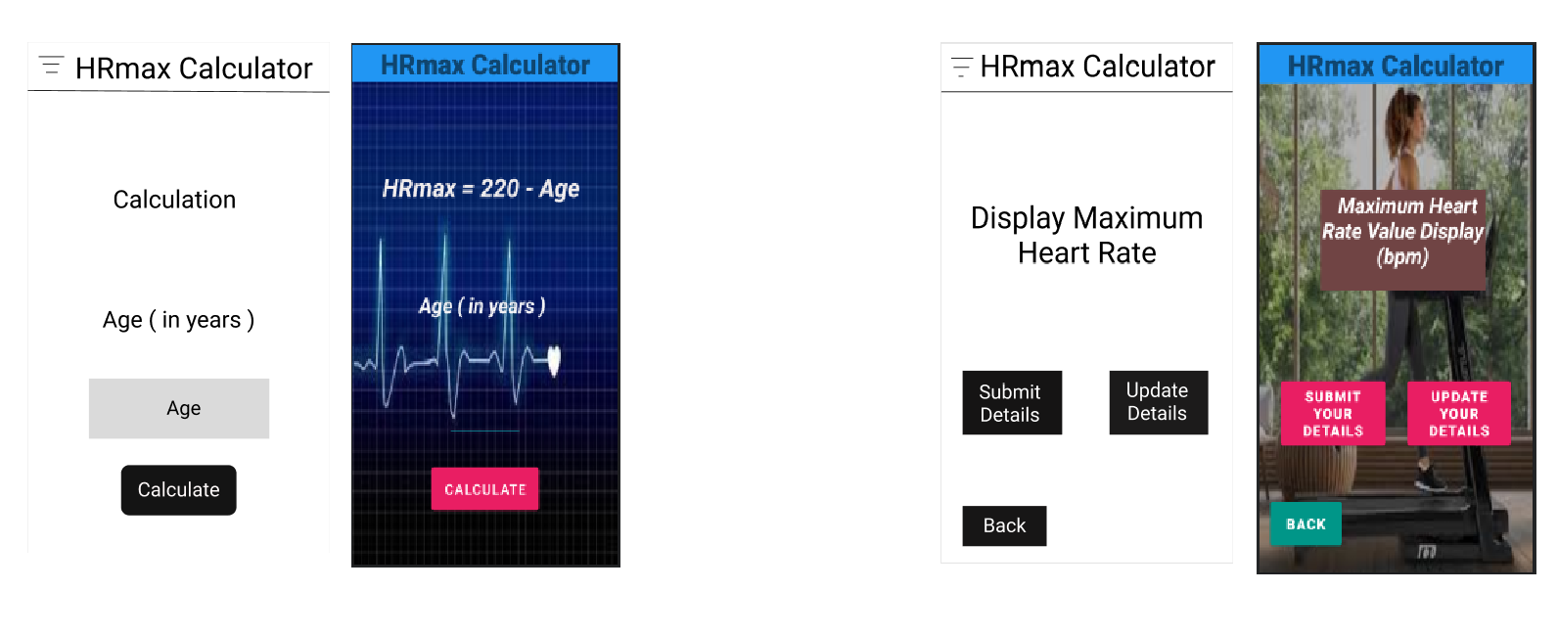

Then displaying her/his maximum heart rate value in bpm. After user wants update or submit user wants to use this buttons.

If the user wants to calculate his/her maximum heart rate firstly user needs to add age in this.

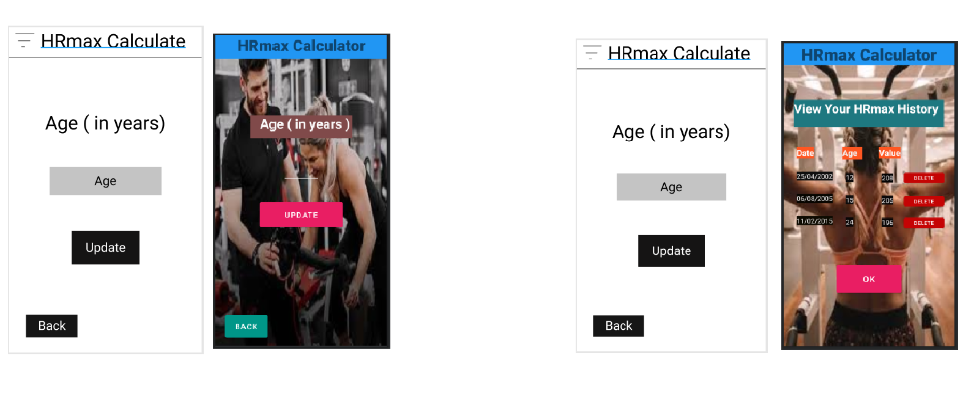

Or user wants to submit user can submit his/her data in history like this. Then user can delete any displaying value in history using delete button.

If user wants to update age user needs to fill this and update.

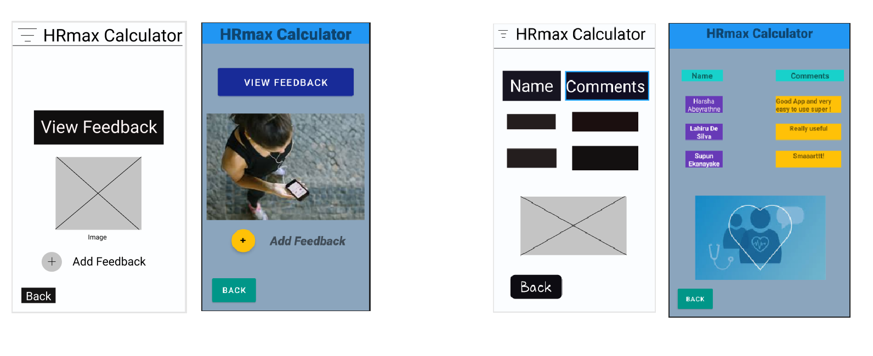

User wants to view feedbacks it’s displaying list of comments like in this .

If user wants to know about how this works or tell about his/her comments user needs to use this add and view buttons.

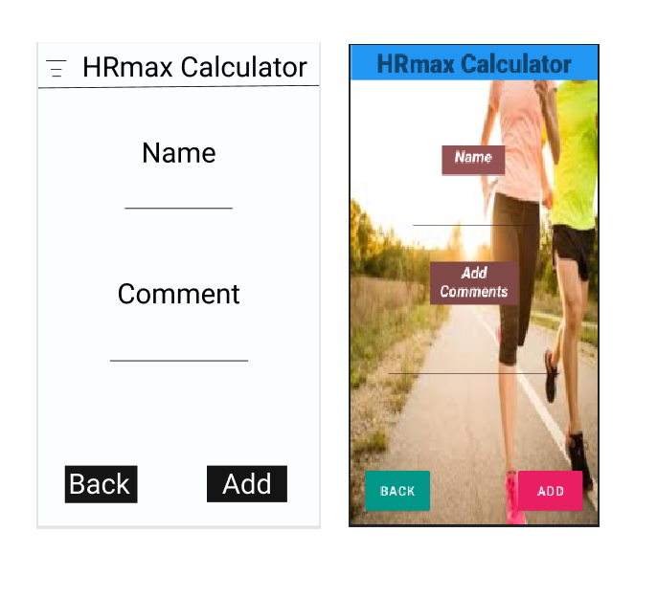

If user needs to add feedback his/her needs to fill this form.

**Usage of resource files**

<?xml version="1.0" encoding="utf-8"?>  
<resources>  
 <color name="purple_200">#FFBB86FC</color>  
 <color name="purple_500">#FF6200EE</color>  
 <color name="purple_700">#FF3700B3</color>  
 <color name="teal_200">#FF03DAC5</color>  
 <color name="teal_700">#FF018786</color>  
 <color name="black">#FF000000</color>  
 <color name="white">#FFFFFFFF</color>  
</resources>

**CRUD operations and functionality of the components**

My part in our Project is Maximum heart rate calculation and handling the feedback .

The principles and components I used are simple and unique in the mobile mindset. Components I have to use are common and must used contents of global guidelines in current and the past also. Components I using for this project like confirming details , keyboard using are the principles of inputs and identification. I using icons8 for get icons to my function because it’s very easy to find any icon if we want . Not only icons we want there are shapes, images, buttons and different things have to use. After the all these things we can done smartly our part.

In this project maximum heart rate calculate and feedback parts is one of main functions in this project. These two mainly working on user who using this. Firstly user wants to input his/her age in given area. After the adding age and wants to go with calculate button to displaying his/her maximum heart rate value then displaying it. If user added her/his age not correctly user can update age or added age is correct then user can submit her/his maximum heart rate value using submit button. After the submitting automatically displaying your maximum heart rate values history. In history part user have option to delete there any value in history.

Next part is feedback part after using or before using user can view feedback or add feedback using feedback option. There are two parts in feedback is view feedback and add feedback buttons. User can use these things very easy it’s based on basic insert , view , delete and update parts.